Monitoring client experience on a shoestring: Toolkit
Authors: Dr Stephanie Quail and Sophie Henness

Overview

This document
This document is a toolkit that contains the 5 steps to reproducible reporting to help make better use of data. It includes practical steps on how to use R, a free open-source software, to create reproducible reports.
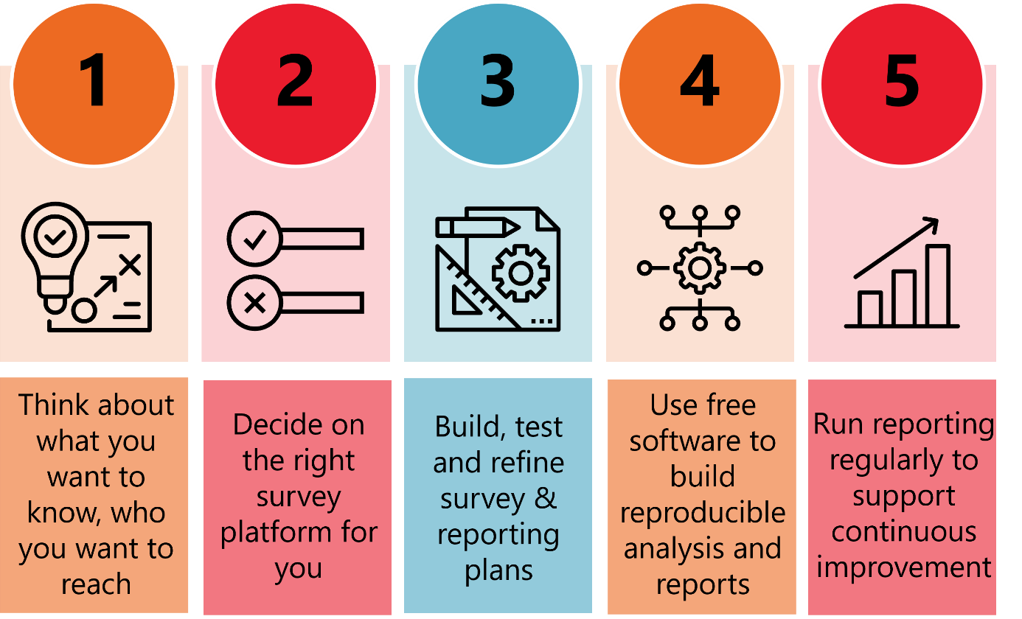

The difference between monitoring and evaluation
Monitoring and evaluation go hand in hand. Monitoring is ongoing while evaluation is typically a point in time measurement to answer specific questions about a policy or program.
- Monitoring is a systematic process for checking progress through readily available data. Data is collected and reviewed regularly while a program/ policy is being implemented. Monitoring data often feeds into evaluation, but monitoring by itself is not evaluation and is less in-depth than evaluation. However, you can structure and analyse your monitoring data evaluatively to help you make more sense of it.
- Evaluation is used to answer specific questions you might be interested in about your program that can’t be answered fully or at all through regular monitoring. The focus of evaluation can be on collecting information about what outcomes have been achieved; the costs and benefits of a program; as a way of accounting for funding; or improving, ending or adapting programs.

The value of monitoring and reporting on client satisfaction
Monitoring client experience is important as client satisfaction is often one of the earliest warning signs of program quality issues – dissatisfaction tends to show up before it fully translates into worse outcomes on program outcome indicators. However, time, resources and the availability of staff with appropriate skillsets make it challenging for many small organisations to build and analyse their own client experience or outcomes survey data in-house. Often data is collected but isn’t able to be used in a timely manner.
Ensuring that client experience data is not only collected, analysed and reported on in an engaging and relevant manner is important for giving decision-makers, managers and front-line staff the ability to see, and then act on, up-to-date information about client or service user experiences. It can also help to support funding decisions.

Think about what you want to know, who you want to reach
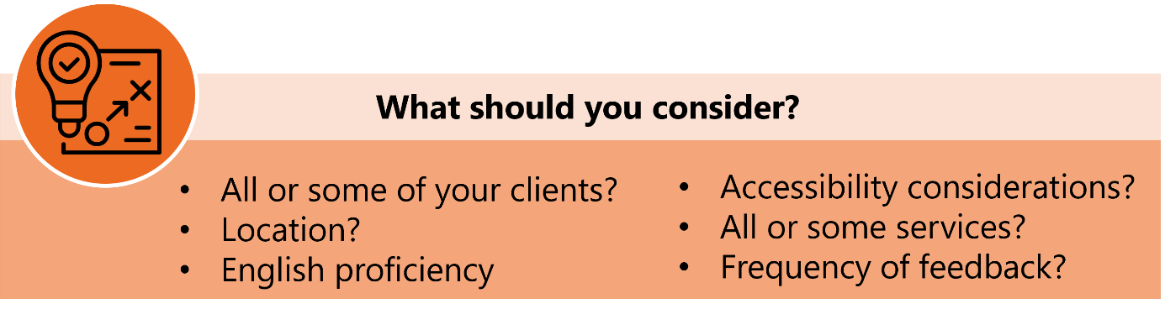
Before creating your survey, take some time to clarify exactly what you want to learn and who you want to hear from. These decisions will shape the questions you ask, how you distribute the survey, and how you analyse the responses.

Think about who you want to provide feedback
All clients or a specific group?
- Decide whether your survey should go to everyone who uses your services, or just to those who have participated in a particular program or activity.
Where are they?
- Consider whether you would like your clients to complete the survey on location where they are engaging with a service or program, or online at a time or place of their choosing.
English proficiency?
- Will all your clients be comfortable responding in English? If not, consider translating your survey into other commonly spoken languages to ensure everyone can participate.
Other accessibility considerations?
- Think about whether clients may need the survey in different formats (such as large print or audio). If clients use screen readers you will need to check that the online survey question format is accessible).
Single or multiple services?
- Are you asking about one particular service, or do you want input on several services or programs?

Consider how often you want to invite feedback from service users
- Consider whether you want to collect feedback after every interaction, only at key milestones (like the midpoint or end of a program), or on an ad-hoc basis as needed.

Plan and design a draft survey
In planning the survey, ask yourself: what do I want to know, and how that is the same or different from what they want to tell me and what information is available to them to recall?
Make it short and easy. Don't require people to think too hard to answer hypotheticals (or make complicated judgments), respect their role in giving their perspectives and your role in making evaluative judgements. For example, ask them what they want from a service - then check this against what the service provides - this would be better than asking them to rate each service on how useful it might be to them if they needed it. They may not know what they would and would not use. They will be led by the questions with socially desirable responses.
Put yourself in their shoes and think what can and do they want to tell you. Don't frustrate them by asking them questions they don't feel really able to answer just because they would provide the answer to a question you or your client has. Their response will likely be unreliable, and therefore invalid.
For further advice on survey design see our ARTD blog:
Critical Foundations of Survey Design | ARTD.

Decide on the right survey platform for you
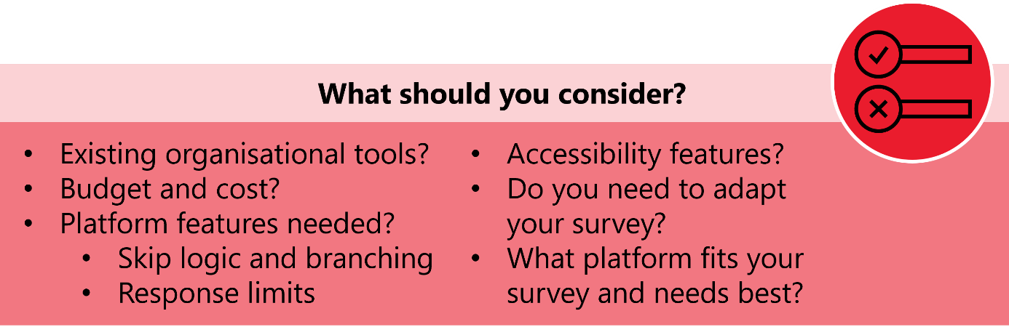
Selecting the right survey platform is a critical step that can affect how easy it is to create, distribute, and analyse your survey. Below are some considerations to help you come to a decision:

Check existing organisational tools
If your organisation already subscribes to a survey platform (such as Qualtrics or SurveyMonkey) or has an established tool that staff and clients are used to, it may be best to stick with it – if it meets your core needs. This can help ensure a smoother experience and consistent data collection across your organisation. Using existing tools may also make it easier to manage data privacy, reporting, and access.

Consider budget and cost
- Find out if there are funds available to pay for a survey platform. Paid survey tools typically offer more features, greater customisation, and better support.
- If there is no budget, free options (such as Google Forms, Microsoft Forms, or SurveyMonkey’s free tier) can still be effective for simple surveys, though they may have limitations on the number of questions, responses, or features.

Review platform features
When comparing platforms, think about the specific needs of your survey and your respondents. Consider the following:
- Number of questions: Some free plans limit how many questions you can include. Make sure the platform you choose can accommodate your survey length.
- Language options: If your survey needs to be available in multiple languages, check if the platform supports this feature. Or ensure it can support multiple surveys in different languages.
- Skip logic and branching: Do you need to show or hide certain questions based on previous answers? Not all free platforms support this.
- Response limits: Many free plans limit the number of responses you can collect. Make sure this fits your expected audience size.
- Accessibility: Make sure the platform works well on mobile devices and is accessible to your clients.

Match your survey to the platform (or vice versa)
Adapt your survey
- If you’re using a free tool with certain limitations (such as a limit on the number of questions or lack of skip logic and branching), consider simplifying your survey or breaking it into multiple shorter surveys.
Choose a platform that fits
- If your survey does require complex features, it may be worth investing in a paid platform that meets all your needs.
Table 1. Examples of available survey platforms and their considerations
Survey platform | Free? | Benefits | Limitations
Google forms | ✔ | - Unlimited responses and duration  - 200 question limit per form  - Has some basic survey logic e.g. branching | - No advanced survey logic e.g. conditional logic, text piping  - 200-question limit  - Questions and responses of the Google Form are in the language they are written.
Qualtrics | ✔ (option) | - Very powerful survey logic, including display, branch and skip logic  - Good options for translated surveys | - Paid account is expensive  - Free version limits features and responses per survey
Survey monkey | ✔ (option) | - Supports skip logic and more advanced branching | - Free option is limited to 10 questions per survey and limited responses per survey.
Jotform | ✔ (option) | - Supports skip logic and more advanced branching | - Free option is limited to 5 surveys and 500 responses.
Accessible Surveys | ✘ | - Very powerful survey logic, including display, branch and skip logic  - Strong accessibility features – including the ability to offer accessibility options to respondents such as Easy Read mode, Sign Language mode, Read Aloud mode, and display options.  - Respondents can use their voice to answer (text-based) questions. The voice answer is automatically converted to text and is part of the survey dataset. | - Expensive – although their website notes that small NFPs, charities or educational institutions can contact them for special pricing.

Build, test, and refine survey & reporting plans
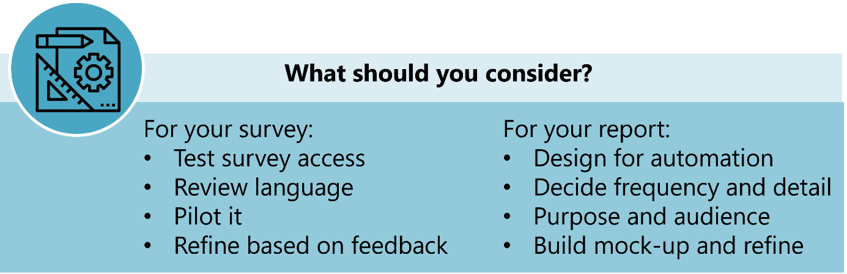

Survey testing and refinement
After designing your survey and building it in your chosen platform, it’s crucial to thoroughly test and refine it before launch. Careful testing helps ensure the survey is user-friendly, accessible, and capable of collecting reliable, actionable data that meets your needs.
Set up the survey
Use your selected online platform to build the survey, adding any necessary display logic (e.g. questions that only appear based on previous answers) and accessibility features (such as screen reader compatibility, large print options, or translations into other languages).
Test survey access
Make sure it’s obvious and straightforward for users to access the survey.
- For in-person feedback, try QR codes on posters, flyers, or tablets in waiting rooms.
- For remote feedback, consider distributing the survey via email, SMS, website links, or client portals.
- Test all access points to ensure links or QR codes work as intended, and the survey loads properly on different devices (phones, tablets, computers).
Review language and clarity
- Carefully read through every question and instruction to ensure the language is simple, clear, and free of jargon.
- Check that all questions are relevant to the respondents’ experiences and that there is no ambiguity.
- If you are offering the survey in multiple languages, check the translations for accuracy and clarity.

Validate display logic
- If your survey uses display logic or branching, thoroughly test all possible paths through the survey.
- Ensure that respondents only see questions relevant to them, and that the logic flows as intended.
Pilot the survey internally
- Share the draft survey with colleagues, team members, or relevant stakeholders in your organisation.
- Ask them to complete the survey as if they were clients, noting any confusion, errors, or technical issues.
- Collect feedback on whether the survey is likely to capture the data they need.
Pilot the survey externally
If possible, run a small test with a few clients or representatives from your target audience. Ask for feedback on:
- how easy it was to access and complete the survey
- whether the language and questions were clear and respectful
- any technical or accessibility issues encountered.
Refine based on feedback
- Review all feedback collected from internal and external pilots.
- Make necessary changes to question wording, survey structure, display logic, or accessibility features.
- If significant changes are made, consider a second round of testing.

Report design and refinement
When designing reports that will be automatically generated, it’s important to create templates that are robust, reusable, and require minimal manual intervention or tailoring.
Design for reusability and automation
- Structure your report so it can be generated automatically at the decided reporting intervals.
- Avoid including manual elements in the report that require frequent updates or adjustments.
- Include analyses that can be reliably reproduced. For example, avoid features like word clouds that tend not to reproduce well.
- Focus on clear, repeatable metrics (e.g. average satisfaction scores, percentage of positive responses) that are easy to compare over time.
Decide on the level of detail and frequency
- Consider how much information is necessary for your audience to make informed decisions. Too much detail can be overwhelming; too little may not be actionable.
- Think about how often your audience needs updates (e.g. monthly, quarterly, or after specific program milestones), and how frequently you are planning to request feedback from clients or service users. Design the report to surface key trends and changes at these intervals.
Know your audience
- Determine who will be viewing and using the report (e.g. managers, front-line staff, executive leadership, or funders).
- These different audiences may have different information needs. For example, management may want big-picture trends, while front-line staff might need more granular feedback on specific services.
- Ensure you consult with each of the audiences who will be using the report so you understand their needs.
Track key indicators over time
- Identify the most important indicators from your survey to track consistently in every report (such as satisfaction scores, response rates, or specific outcome measures).
- Use charts, graphs, and tables to show changes over time. This helps users of the report to quickly spot patterns or areas needing attention.
- Consider how you will manage privacy in the reporting of these key indicators – to ensure that no individual can be identified through their responses. For example:
- watch cell-sizes in any crosstabs you create using demographic data. A typical threshold is not reporting on sub-groups with fewer than 5 respondents.
- consider the granularity that you report on, particularly when reporting on demographic data. The more fine-grained detail you collect and report on a demographic variable (e.g. age), the easier it can be to identify individuals. Reporting on variables grouped into larger bands (e.g. age brackets) can minimise this risk.
Build and test a report mock-up
- Before creating your report in RMarkdown (more on this below), draft a mock-up of the report using sample or historical data. This helps you visualise what the final output will look like and ensure it aligns with the needs of your audience.
- Share the mock-up with the intended audience for feedback. Ask:
- Is the information clear and easy to understand?
- Does the report answer their key questions?
- Are there unnecessary details, or is anything missing?
Refine and finalise
- Adjust the report layout, level of detail, or data visualisations based on feedback.
- Make sure the final automated report template can be used repeatedly without further customisation.
Throughout the design and testing process, engage with report users to build a shared understanding of what information is most useful, how it should be presented, and how it will support decision-making.

Use open-source software to build analysis and reporting
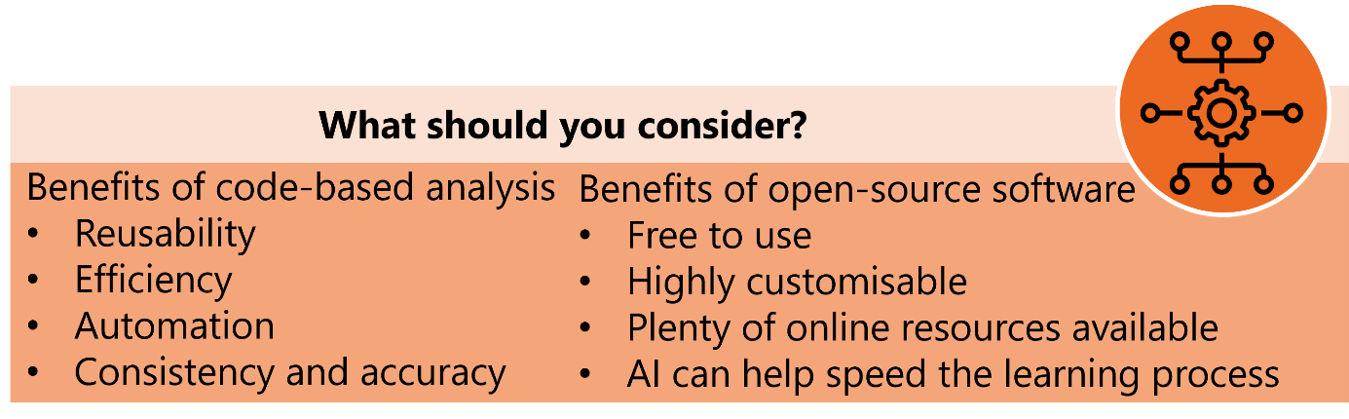

Why Use Open-Source Tools?
To maximise the value of your survey data, we recommend using open-source software—specifically, R and RStudio—to create code-based, reproducible analysis and reporting workflows. Open-source tools are free and highly customisable. This makes them a robust choice for organisations with limited resources.
There are some key tools that we suggest for automated reporting:
- R: A statistical programming language widely used for data analysis.
- RStudio: A user-friendly environment for R, which makes coding, data management, and visualisation more accessible.
- RMarkdown: A tool within RStudio that lets you blend text, code, tables, and figures in a single document.
- Knitr: An R package that executes code chunks in RMarkdown, producing dynamic reports in Word, PDF, or HTML formats.

Benefits of Code-Based Workflows
- Reusability: Monitoring surveys typically have a consistent structure—over time, you simply collect more responses (rows), but the columns (questions and metrics) stay the same. This consistency means you can build your analysis and reporting code once, then reuse it each time you want to analyse your data.
- Efficiency: The initial investment in setting up your code pays off quickly. Once it is built, generating future reports is as simple as clicking a button—saving significant time and reducing manual effort.
- Automation: You can automate the entire process, from importing live survey data (e.g., directly from Google Sheets, Excel, or a database) to cleaning, analysing, and visualising results.
- Consistency and accuracy: Automated workflows reduce the risk of manual errors, and ensure that each report uses the same methods and formats.

Getting Started and Overcoming Barriers
We understand that using code-based solutions for analysis and reporting can seem intimidating if you’re new to programming. However, access to templates and some step-by-step guidance (see our R report guide below) can help.

Building reproducible reports using R and RStudio
This section provides step-by-step instructions on generating the report using R and R studio.
First install R and RStudio and the required packages following the instructions below. Open the report in R and run it. After running the Report in RStudio, the output will be a fully formatted Word document that serves as the final report. This document includes all the generated tables, graphs, and translated survey responses, automatically compiled based on the input data and code.

Installing R and the necessary packages
- Download R and RStudio
- Link here for instructions: A Installing R and RStudio | Hands-On Programming with R
- Open RStudio
- Install R Packages:
- Click on the Tools menu at the top
- Select Install Packages…
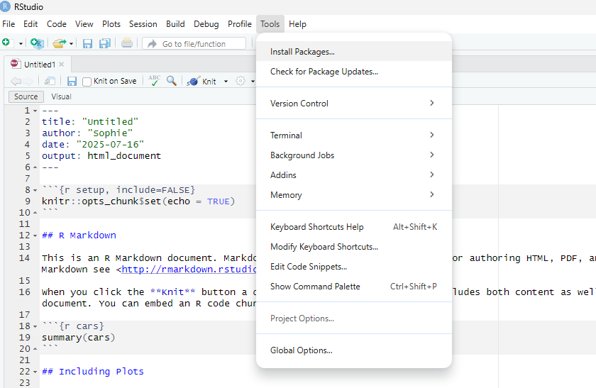
- In the box that pops up, paste the following list: tidyverse, readxl, summarytools, haven, janitor, lubridate, writexl, gtsummary. If you want to use different packages as you build your code you will need to install these prior to running your code.
- Click Install

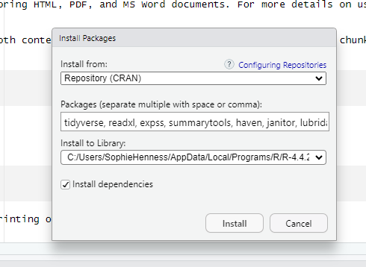
Once you have installed the packages, you don’t need to do this again

Saving the report
Important: Make sure your files are in a folder that is kept on your computer (e.g. your desktop) or somewhere that you can navigate to via file explorer (e.g. a folder synced to your desktop from Sharepoint). The files cannot be kept only on your intranet/the cloud.

Download your survey data

Step 1 – Download the data
To start, you will need to download the responses from your survey platform. You need to save the data in a data folder, separate from the folder you are keeping the code in. Depending on the survey platform you use, you may also be able to read survey data into R directly using code.
Important: Please make sure you have closed all of the survey data files before you open the report in R.

Step 2 – Open the report in R
To open the report in R:
- Open your code folder
- Click on the .Rproj file
- Your report will open in R

Running the report
Now you have your report open in R it should look like this:
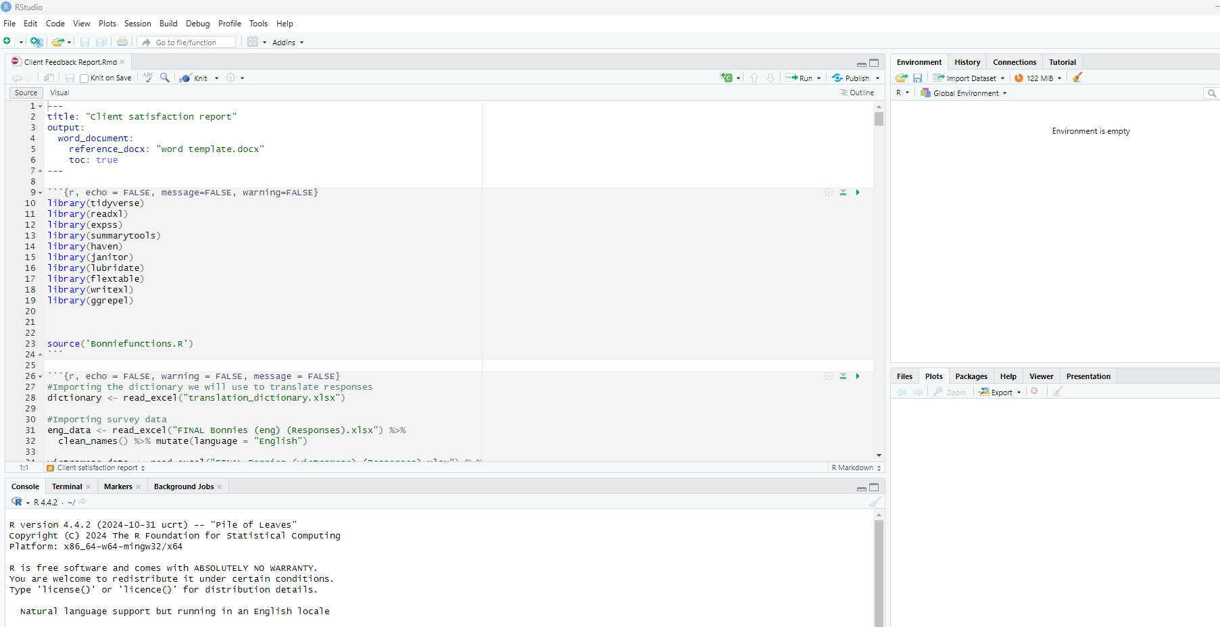

To run your report:
- Click on the “Knit” button at the top of your report window
- Click on “Knit to Word”
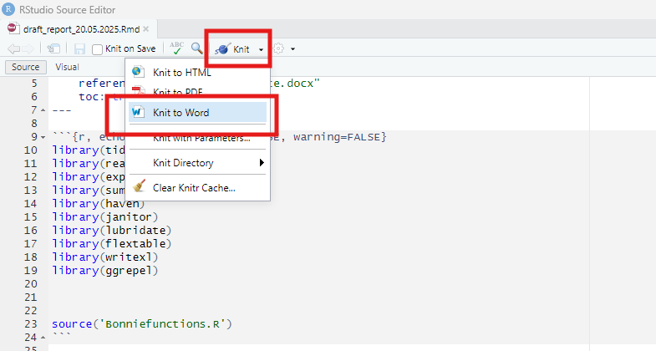
- After it is knit – do a visual check to make sure it looks right
- Copy that report and move it into a separate folder and name it using the date
Your report has been run and should output into a Word document.

Fixing issues
Sometimes, errors can occur while running code in R. In this section there are some practical tips for troubleshooting and resolving them effectively.
ChatGPT, or your preferred AI tool, can be very helpful for understanding any error messages that may pop up
- Just copy and paste your error message into the AI chat box.
Common issues and checks:
- Make sure all the Excel documents and Word templates are closed before you run the report.
- Make sure all your files have the correct name

Regular reporting & continuous improvement
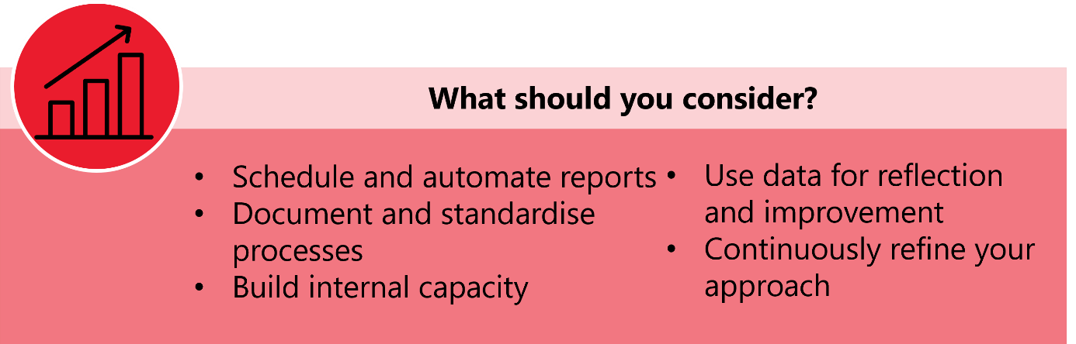
Building a meaningful client experience monitoring system isn’t a ‘set and forget’ exercise. To ensure your survey feedback drives ongoing service improvement, it’s essential to establish regular reporting routines and foster a culture of reflection and adaptation.
Schedule and automate reporting cycles
- Decide how often you’ll run the analysis and generate reports—this could be monthly, quarterly, or after each program cycle, depending on your needs and how frequently you will ask your clients or service users for feedback.
Document and standardise processes
Write step-by-step guides detailing:
- when to pull new survey data
- how to run the analysis and reporting code
- where to store and share the resulting reports.
This documentation ensures consistency and helps onboard new staff.
Build internal capacity
- Identify and train one or 2 additional staff members to run the reporting workflow. This reduces reliance on any single person and builds capability in your team.
- Work to build data literacy in your organisation more broadly. Understanding how data can be used, and how to interpret (and importantly, not over-interpret) results is critical to ensuring your organisation can make the most of client experience data. This may look like:
- a brief introduction to the client experience survey, why it is important, and how it will be used, for frontline staff who will be involved in administering/ distributing the survey
- a short methods primer for staff involved in running the workflow
- standard language in every report that explains response rate and limitations upfront
- iterative check-ins about how to interpret the results, response rates, and other considerations (e.g. whose voice is missing, what may be important and not captured through the survey).
Go beyond routine reporting
- Schedule occasional, more detailed analyses, especially of open-text (qualitative) responses. For example, you could review comments on a set schedule to identify emerging themes or unexpected issues.
- Consider conducting additional analyses when new questions or concerns arise from leadership, staff, or clients.
Use data for reflection and improvement
- Use your regular reports to monitor key metrics and open-text themes. Are there improvements or declines in satisfaction? Do the same issues keep coming up?
- Bring the results to regular team meetings. Discuss what’s working well, where challenges persist, and brainstorm potential changes.
- Before making changes, consider if what you are observing is a trend or an outlier. Use the response rates (or number of responses if you aren’t collecting feedback from all clients in a particular cohort) to get a sense of whether this is likely to be representative of your clients or service users overall – or whether you need to gather more information before acting.
- If you have a client or consumer advisory group, consider involving them in the interpretation and reflection process. They will have important insights.
- Communicate back to clients and staff about what you’ve learned and any changes you’re making as a result of their feedback.
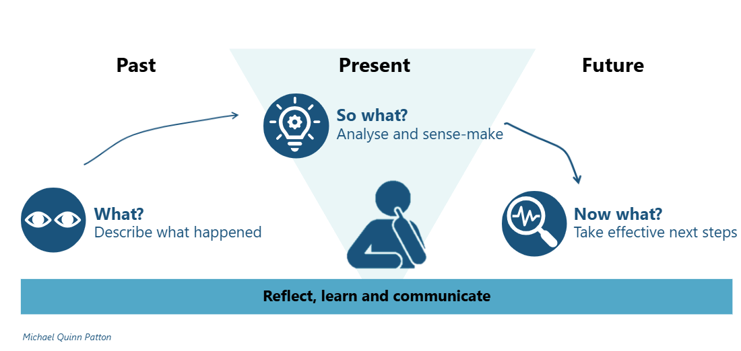

Continuously refine your approach
- Periodically review your survey, analysis, and reporting processes:
- Are the right questions being asked?
- Are the reports useful and accessible to decision-makers and other staff?
- Is the analysis capturing what matters most?
- Consider how you can complement your survey reporting by analysing and reporting on relevant administrative data. Both direct client experience and administrative data are important to informing action.
- Make improvements as needed based on feedback from both report users and survey respondents.

Establishing regular, well-documented reporting routines and embedding a cycle of reflection ensures your client experience data is not just collected but put to work for meaningful and ongoing improvement.

